**Assignment 1 SILL system**

**Class: ITC322**

**Student Name: Aaron Brody**

**StudentID:** **11574516**

**Session:201830**

Java Single integer linked list guide

When you run the Main program SILL.Java, if you feed the program an argument of the text file containing numbers in it, it will use that file to seed the input, otherwise it will load the menu.

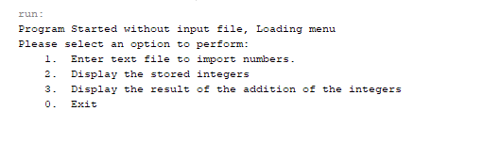

At the menu, if you enter 1 It will request an input file path.



If you enter a file with invalid characters, It will tell you that there were invalid characters, and return to the menu

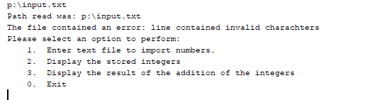

if you enter a bad file name it will also tell you that a bad filename was read, then return to the menu.



When a valid entry is performed, it outputs the below, then displays the menu again.

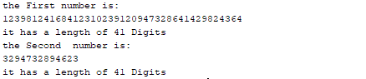

If you enter option 2 and no numbers are selected it will tell you that theres no numbers and you need to load the menu again.

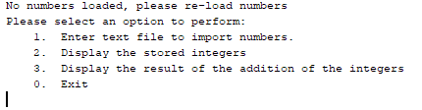

If you have input loaded, it will display the stored integers.

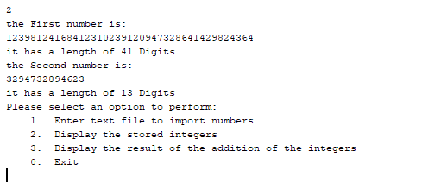

If you press 3 and no numbers are loaded it will tell you to load new numbers otherwise it will display the numbers.

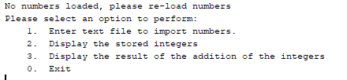

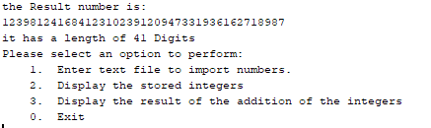

Pressing 0 exits the program.

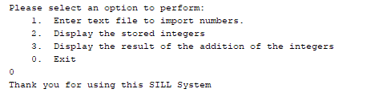

Entering any other number or character asks for a more valid input.

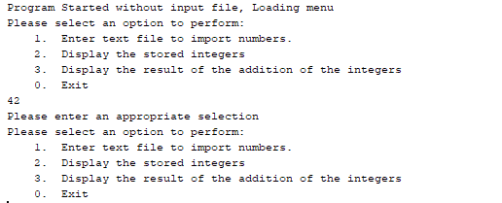

Design Considerations.

I decided to store the integers as little endian, so that when performing the addition, I could easily retrieve the next number.

I created a toString() method, to enable printing the linked list in order.

I decided that the header node, would not contain any of the number but would have a flag to indicate that the value was positive or negative.